|  |  |
| --- | --- |
| **15D019 - Problemset 1**  Basic Demand Estimation | Carlos Isaac Rodriguez Prado  Hans-Peter Höllwirth  Veronika Kyuchukova |

**Part 1: Data check**

**Exercise 1**

The price variable can be interpreted as the average sales price in USD per 1 lb for a given week and a given region.

**Exercise 2**

The mean prices (in $) across weeks for Hellman’s and Kraft in the Jewel and the higher aggregation Central region are:

|  |  |  |
| --- | --- | --- |
|  | Jewel | Central |
| Hellman's 32 oz | $ 1.114487 | $ 1.086778 |
| Kraft 32 oz | $ 1.094971 | $ 1.088719 |

The average prices between Jewel and the Central region can be compared, although one need to be careful because the average for the Central region was computed over a longer period (16 more weeks). Also note that Jewel sales form part of the higher aggregated Central region sales, thus, if one would take out the Jewel sales, the average price in the Central region would be lower than the computed prices above.

**Exercise 3**

The standard deviations (in $) across weeks for Hellman’s and Kraft in the Jewel and the Central region are:

|  |  |  |
| --- | --- | --- |
|  | Jewel | Central |
| Hellman's 32 oz | $ 0.06682887 | $ 0.03677853 |
| Kraft 32 oz | $ 0.1117225 | $ 0.05426573 |

The standard deviation of prices in the Jewel region are about twice as high as in the Central region. This could be attributed to the fact that the Jewel region is smaller (in fact it is a sub-region of Kraft's "Central Region") with less observations, so each observation has a higher influence on the variance.

This tells us that the estimate of the elasticity at Jewel will be less precise because the variance of the estimator will be larger:

$$var({\hat{β}}_{x})=σ^{2}/(\sum{(x_{i}-\overline{x}})$$

**Exercise 4**

The time-series plots below show the prices (in blue) and corresponding sales (in red) for both Kraft and Hellman’s in the Jewel and Central Region.

TBD: describe the differences or similarities between Kraft and Hellman's pricing policies in each account

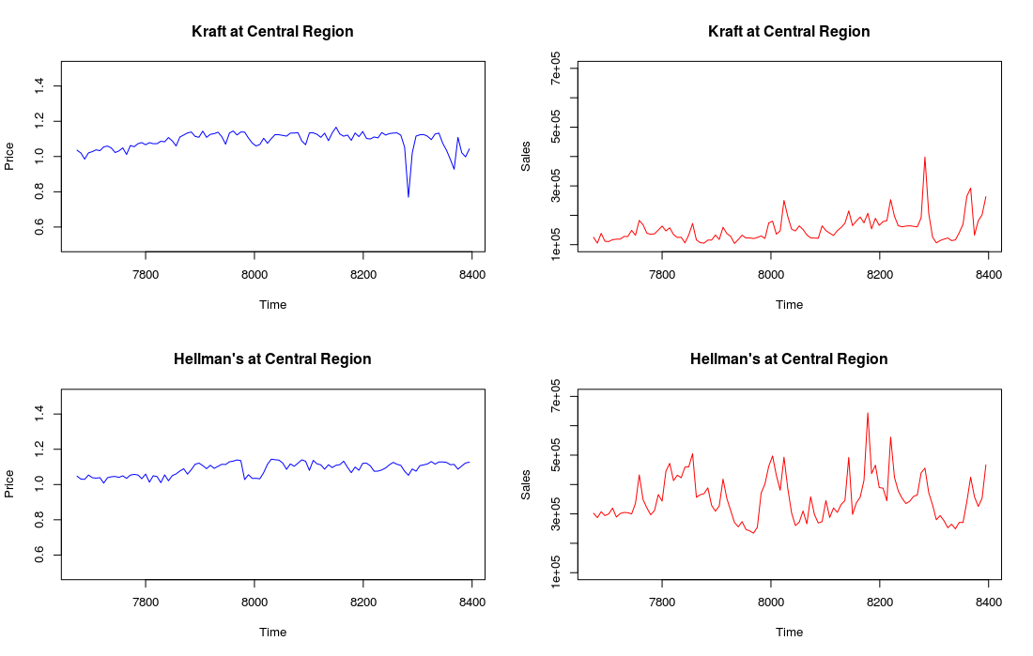

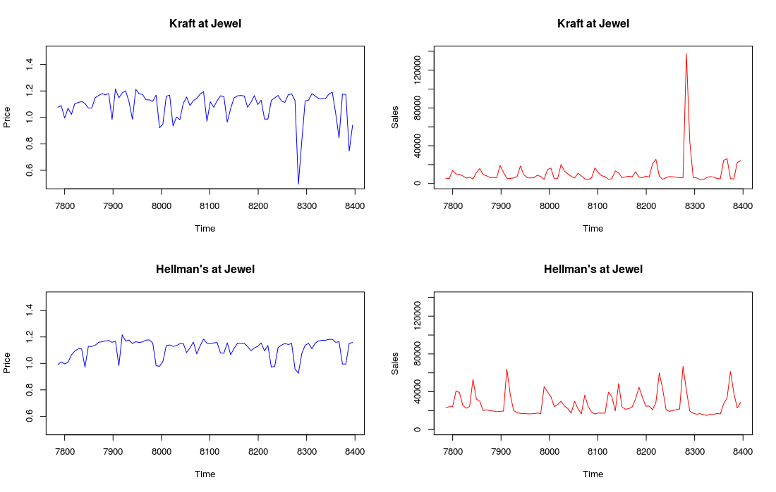

**Exercise 5**

The scatter-plots below give evidence that the demand-curve in the data is negatively sloped for both regions and brands. For both Kraft and Hellman's, demand appears to be more elastic in the Central region.

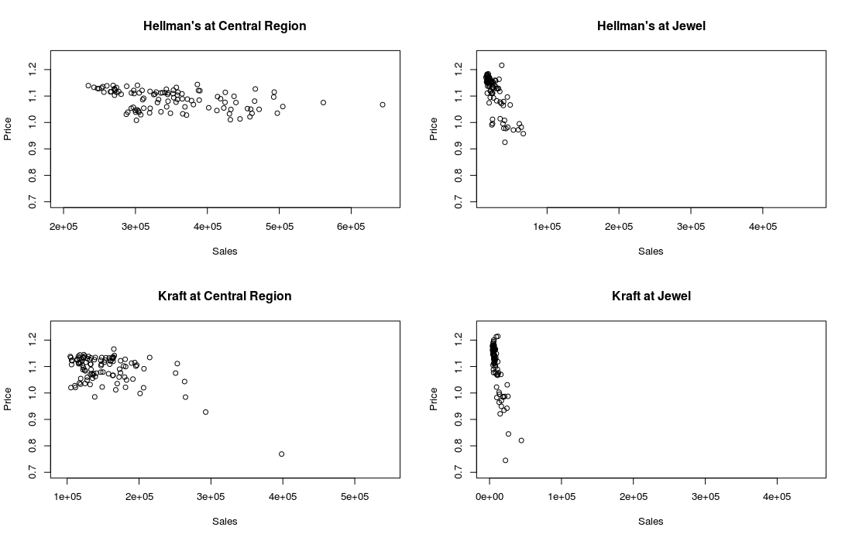

**Part 2: Demand estimation**

**Exercise 1**

Fitting the "multiplicative" demand model for Hellman's and Kraft at Jewel produced the following demand curves:

|  |  |  |
| --- | --- | --- |
| **Jewel** | ln(A) | Eta |
| Hellman's 32 oz | 10.60443 | 4.58359 |
| Kraft 32 oz | 9.39761 | 4.16721 |

TBD: curve plot

**Exercise 2**

Fitting the "multiplicative" demand model for Hellman's and Kraft in the Central region produced the following demand curves:

|  |  |  |
| --- | --- | --- |
| **Central** | ln(A) | Eta |
| Hellman's 32 oz | 12.94772 | 2.37654 |
| Kraft 32 oz | 12.08333 | 2.10567 |

TBD: curve plot

**Exercise 3**

The demand elasticity is higher in the Jewel region for both products. Potential explanations for the difference are:

* **Income**: The income level in the Central region in average could be higher than the average income level in the Jewel region. People with higher income spend a lower proportion of their income when buying the same quantity of a product than the people with a lower income. This difference makes richer people be more inelastic to changes in prices.
* TBD: more reasons to be added

**Exercise 4**

For Kraft, the % change in unit sales for a 10% increase in the price at Jewel is

$$\frac{Q_{1}}{Q_{0}}=\frac{{A(1.1*P_{0)}}^{-η}}{{A(P_{0)}}^{-η}} ={1.1}^{-4.16721} = 0.672214674$$

Thus, a 10% increase of the price at Jewel would result in a projected 32.78% reduction in demand of Kraft’s 32 oz Mayo.

For Hellman’s, the % change in unit sales for a 10% increase in the price at Jewel is

$$\frac{Q_{1}}{Q_{0}}=\frac{{A(1.1*P_{0)}}^{-η}}{{A(P_{0)}}^{-η}} ={1.1}^{-4.16721} = 0.672214674$$

Thus, a 10% increase of the price at Jewel would result in a 35.39% reduction in demand of Hellman’s 32 oz Mayo.

**Exercise 5**

Fitting the "multiplicative" demand model for Hellman's and Kraft at Jewel, allowing for cross-price effects produced the following adjusted demand curves:

|  |  |  |  |
| --- | --- | --- | --- |
| **Jewel** | ln(A) | ln(Own price) | ln(Competition's Price) |
| Hellman's 32 oz | 10.59981 | -4.69471 | 0.19563 |
| Kraft 32 oz | 9.22113 | -4.43880 | 1.87135 |

TBD: plot

**Exercise 6**

Kraft's 32oz Mayo sales are more "vulnerable" to the pricing policy of Hellman’s. This can be deduced by the far higher cross price elasticity of 1.87135 as compared to 0.19563 (which actually is not statistically different from zero). Kraft's sales are projected to decrease by 1.87% on average for each 1% decrease in Hellman’s prices whilst Hellman’s sales won't be affected by changes in the prices of Kraft.

**Exercise 7**

Our colleague is likely to be wrong. Any of the factors he mentioned (such as weather and traffic) do impact both Kraft and Hellman's sales equally and therefore should not have any influence on the cross-price effects. He is right that if there is a factor that impacts sales of both brands differently, than this factor would need to be included in the model, however, we could not identify such a factor.

**Exercise 8**

Assume that Hellman's price is cut by 10% at Jewel. The demand for Kraft before the price changes is:

$$D_{K}^{0}=exp(9.22113){(P_{K})}^{-4.4388}{(P_{H})}^{1.87135}$$

On the other hand the new demand after Hellman's 10% price decrease, as a function of Kraft's price change is:

$$D_{K}^{1}=exp(9.22113){({i*P}_{K})}^{-4.4388}{({0.9*P}_{H})}^{1.87135}$$

where $i$ accounts for the change in the price of Kraft’s products. Since we want to keep the sales unchanged after these changes, $D_{K}^{1}$ has to be equal to $D_{K}^{0}$:

$$exp(9.22113){(P_{K})}^{-4.4388}{(P_{H})}^{1.87135} =exp(9.22113){({i*P}_{K})}^{-4.4388}{({0.9*P}_{H})}^{1.87135}$$

$$i=i^{-4.4388}{0.9}^{1.87135}$$

$$i={0.9}^{1.87135/4.4388}$$

$$i=0.9565532$$

Thus, Kraft has to lower its price at Jewel by 4.35% in order to keep its demand unchanged after Hellman’s price reduction.